

HEAVY-DUTY DRAWER
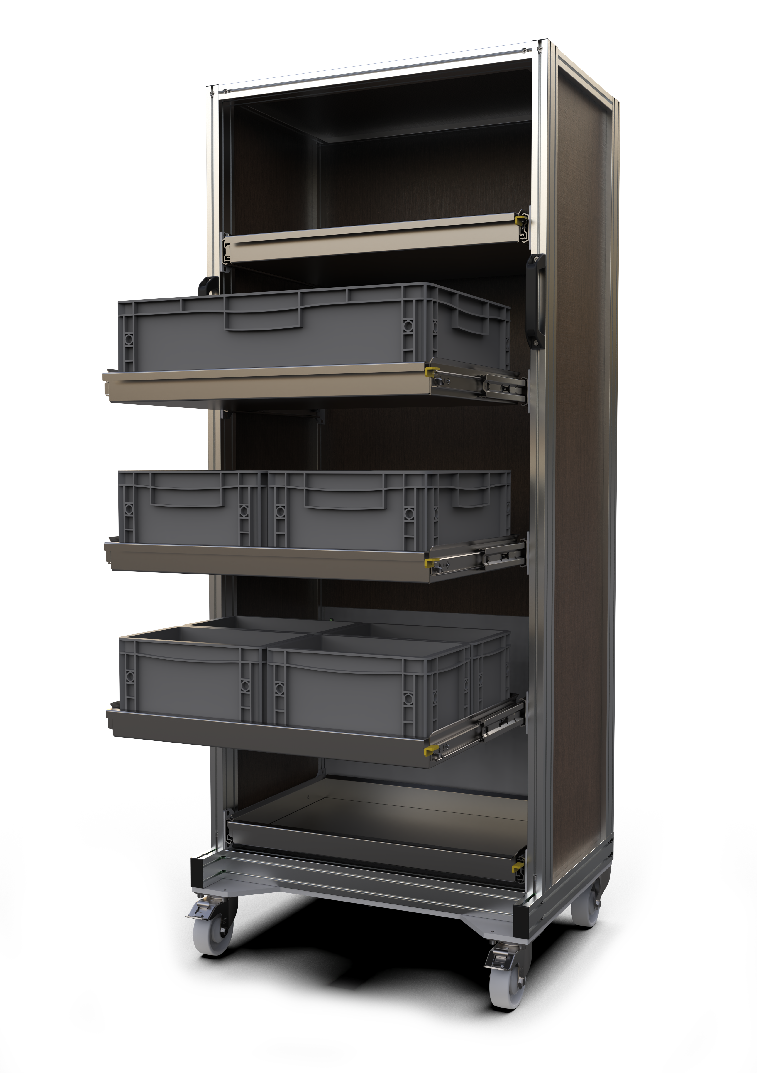MOBILE RACK

PRODUCT SAFETY

Manufacturer:
Name: INOMECH s.r.o.
Address: Martina Koláře 2118, 390 02 Tábor, Czech Republic
Tel.: +420 725 872 201
Company ID: 26073897
VAT ID: CZ26073897
www.inomech.com

- Risks
Risks arise primarily from reduced stability and the possibility of tipping over while moving the rack. Further risks arise from handling individual drawers. When fully loaded, the total weight of the rack is approximately 600 kg. Such mass has considerable inertia during movement. Therefore, the mobile rack must be used with care and caution, and it must always be moved only at a very low speed. The rack may only be moved by adults, or by minors under adult supervision.
Safe use of the mobile rack is ensured by properly training all persons who will come into contact with the mobile rack, familiarising them with the Operating Manual, this Safety Data Sheet, and any other organisational regulations that reflect the individual conditions of your organisation: a local operational safety regulation.

  - Warnings about risks associated with handling the drawers:
- Improper securing of drawers and their unintended sliding out or in: always check the correct engagement and functionality of the drawer slide lock.
- Overloading of drawers with respect to the orientation of the front swivel wheels: always keep the wheels locked in the forward position.
- Pulling out or pushing in a loaded drawer too abruptly and the resulting dynamic impact of the drawer slide at the top of the rack: pull out and push in drawers slowly while continuously holding them with your hand.
- Injury (crushing, cutting, severing, being drawn in or caught) caused by drawer movement: handle the drawer only by the front part designed for drawer handling.
- When placing parts into and removing them from the drawers, observe safe working practices for lifting and handling heavy objects.

  - Warnings about risks associated with handling the rack:
- Loss of stability and tipping over while moving, or when several drawers are pulled out at the same time.
- Unintended sliding out of drawers during handling: always check that the shelves are secured before moving the rack.
- Unintended shifting of the load on the shelf due to inertia: place rubber on the bottom of the drawer to increase friction, keep the drawer bottom clean and free of oils and lubricants, and prevent rotationally symmetric objects from rolling.
- Sudden loss of stability due to abruptly stopping the rack during handling: before moving the rack, check that the floor is level and free of objects on which the wheels could catch. Check that you will not be crossing steps (stairs, trims, unevenness) that would change the rack's tilt.
- Risk of compressing or crushing limbs and persons by the rack against surrounding obstacles during movement: move the rack at a very low speed.
- Risk of foot injury from the wheels: handle the rack while wearing sturdy closed-toe footwear.
- Unintended rolling of the rack when placed on or moved across an incline: use the wheel brakes, and enlist the help of another adult to stabilise the rack from the opposite side during movement.
- We recommend always moving the rack backwards, as this ensures maximum stability on the swivel wheels. Be prepared for the possibility of the rack tipping over due to a sudden stop when the wheels hit an obstacle. Use the help of a second adult.
- In confined spaces such as narrow corridors, door frames, aisles between furniture and similar, move the rack with the utmost caution. Push the rack by its handles to avoid bruising your hand or crushing or pinching your fingers.
- Move the rack only on a dry, level, clean surface: risk of slipping.

- Measures to minimise risks

- After each move of the rack to a new location, lock the wheels in the forward position using the brakes. A free-standing rack must always be braked!
- Move the rack only on a level, dry and clean surface.
- Place heavy objects preferably in the lower drawers.
- Secure the drawers properly: check that the drawer locks engage correctly before every handling of the mobile rack.
- When needed (handling sharp objects, damaged shelves, exposure to burrs and sharp edges) use non-slip cut-resistant gloves.
- To store sharp objects in the drawers (for example cutting tools), use a device that prevents the object from unintentionally falling out of the drawer: protective covers, a crate, or holders.
- Keep the wheels and brakes clean of debris.
- Report any malfunction, damage, or deformation of the rack or its parts; do not use a damaged rack!

- Operational inspections

- Carry out a regular inspection of the mobile rack once a year: under applicable legislation (Czech Government Regulation No. 378/2001 Coll.), racks must be inspected at least once every 12 months.
- Once a month, or more often if needed, regularly check the drawer slide locks and the correct operation of the running wheels.
- Once a month, or more often if needed, check the presence and integrity of the safety labels: the load capacity markings for the drawers and the entire rack.
- Once a month, or more often if needed, check the operation of the brakes and the wheel swivel lock.
- Once a month, or more often if needed, check load-bearing parts, slides and shelves for deformation; if any deformation is found, immediately empty and take the mobile rack out of service. If a shelf is damaged, dismount it immediately.

- Decommissioning
The rack must be disassembled. Individual parts must be sorted by material and handed over for recycling. Non-recyclable materials must be disposed of in accordance with applicable regulations.

