

HEAVY-DUTY DRAWER
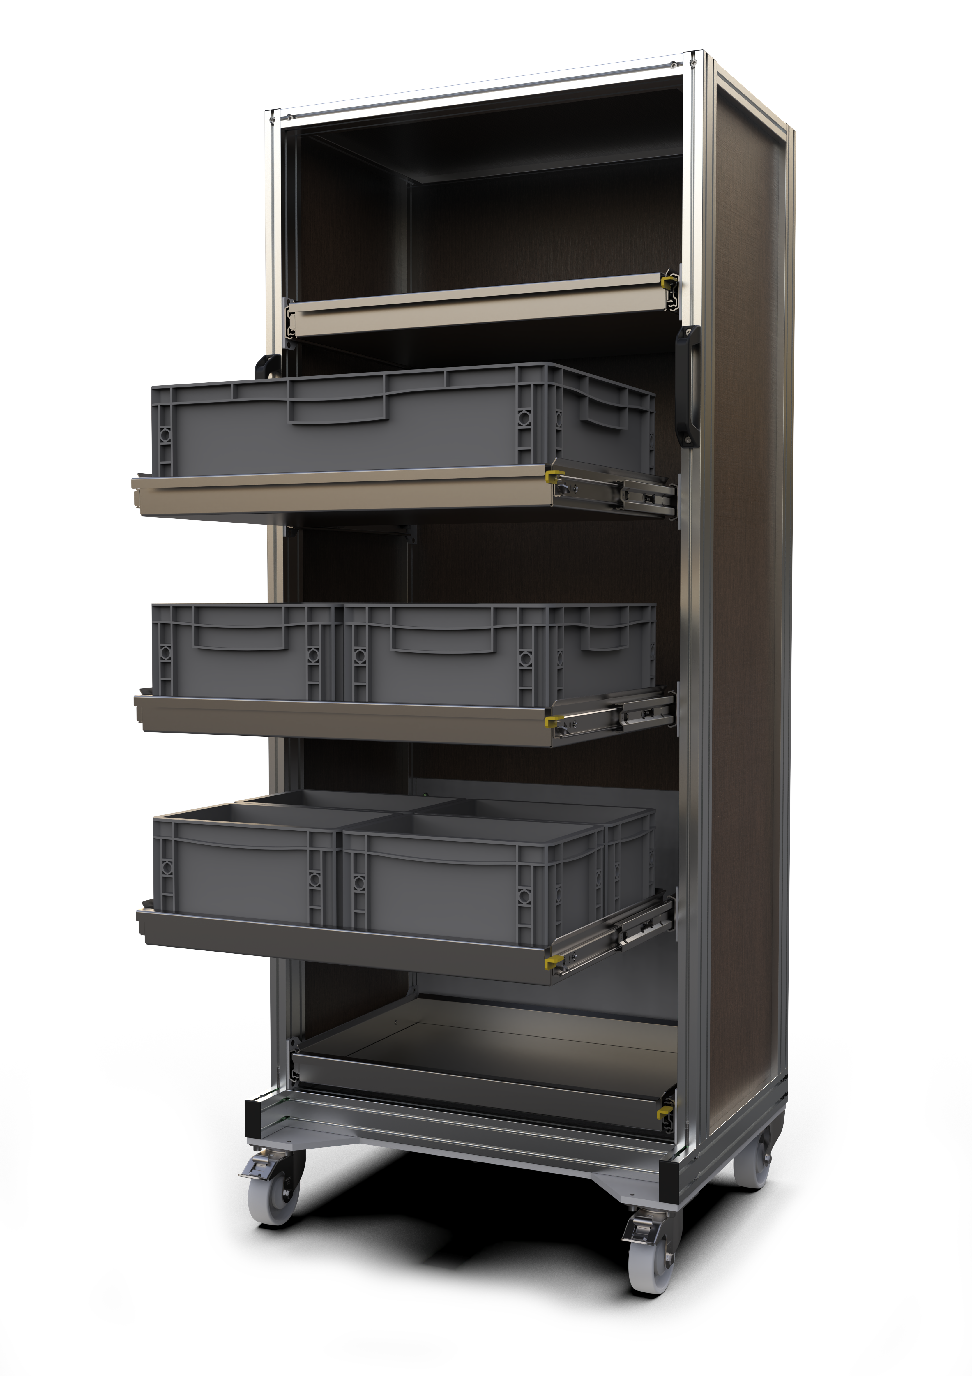MOBILE RACK

USER MANUAL

Manufacturer:
Name: INOMECH s.r.o.
Address: Martina Koláře 2118, 390 02 Tábor, Czech Republic
Tel.: +420 725 872 201
Company ID: 26073897
VAT ID: CZ26073897
www.inomech.com

- Description
The heavy-duty drawer rack is designed primarily for the organised storage and transport of heavy parts, semi-finished products, moulds, tools, instruments, fixtures, and similar items. Its base is a rigid frame made of aluminium profiles. Drawers made of 1.5 mm thick steel sheet are fitted in the frame. The drawers are equipped with ball-bearing full-extension slides that lock in 2 positions. The stability of the rack is ensured by a counterweight, thanks to which up to 2 arbitrary, evenly fully loaded shelves can be extended simultaneously without the risk of tipping over.
- Table of basic parameters
Dimensions W x D x H | 720x620x1750 | mm
Total weight (5 drawers) | 170 | kg
Drawer internal dimensions | 610x405 | mm
Drawer weight | 8.5 | kg
Maximum even load per drawer | 75 | kg
Maximum total shelf load of the rack | 400 | kg
Operating temperature | -10 to +50 | °C

- Centre of gravity and stability
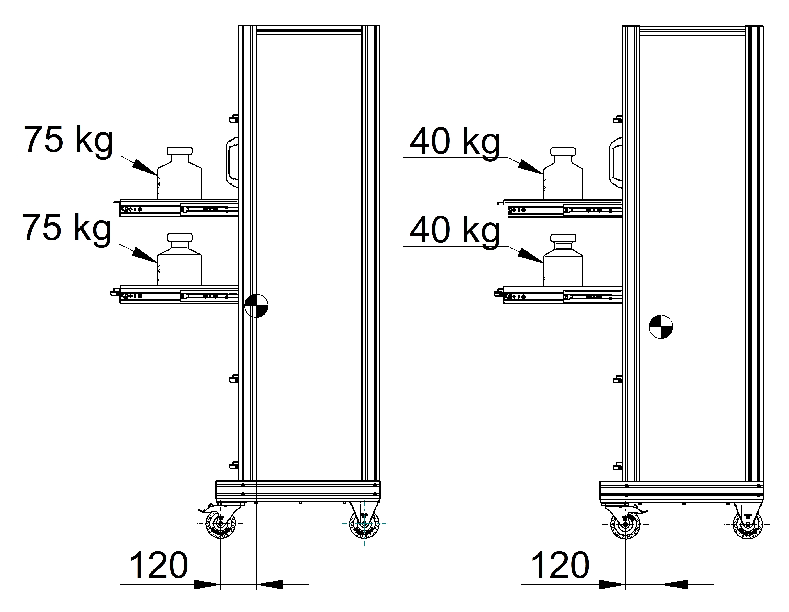
Safe position of the centre of gravity in relation to the load and wheel orientation
Before pulling out a drawer, always make sure that both swivel wheels are braked and locked in the forward position, as shown in the picture on the left. In this position, two arbitrary, evenly fully loaded drawers (2 x 75 kg) may be extended. The rack remains stable in this configuration even when the other drawers are empty.
If the wheels are turned under the rack, as shown in the picture on the right, then to maintain the rack's stability only one fully loaded drawer may be extended, or two drawers each loaded with a maximum of 40 kg (2 x 40 kg).
When handling the rack, always make sure that all drawers are pushed in and properly locked!

If the wheels are turned under the rack (see picture on the right), the rack's stability decreases and extending two fully loaded drawers will cause it to tip over!
Never move the rack with drawers extended or unlocked! The rack may tip over!
The rack's stability is always calculated for an even load in the drawer: the centre of gravity of the drawer contents is in the middle of the drawer bottom.

  - Safety pictogram: explanations
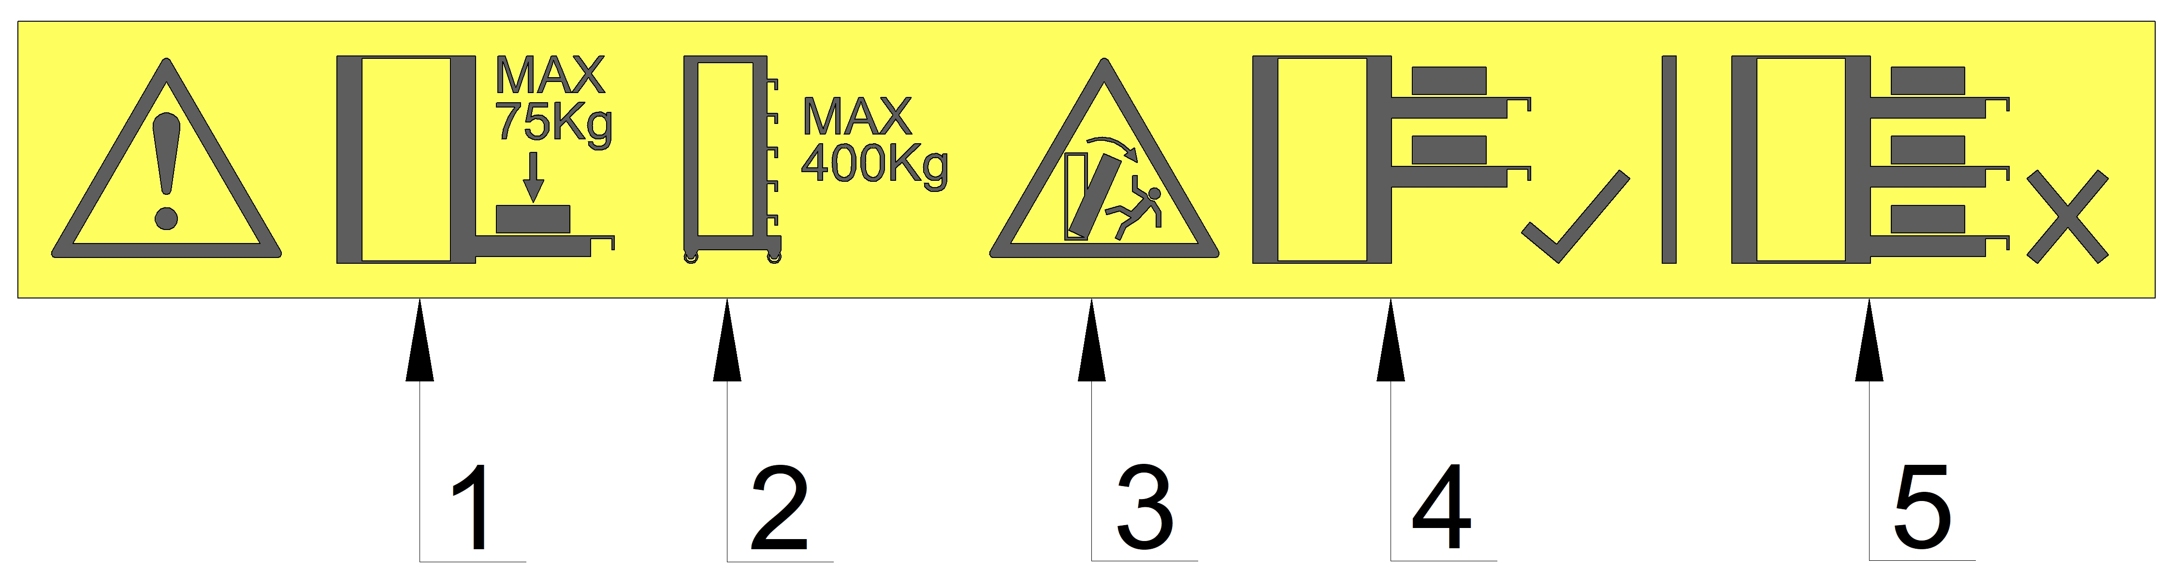

- Maximum even load per drawer is 75 kg.
- Maximum even total load of all drawers in the rack is 400 kg.
- Caution! Risk of tipping over!
- A maximum of 2 evenly loaded drawers may be extended at the same time.
- It is forbidden to extend 3 or more drawers at the same time.

- Handling
Despite its very robust construction, the rack must be handled with care to ensure a long service life. Do not use unnecessarily strong impacts when pulling out or pushing in drawers, especially when they are loaded. Make sure the drawers lock correctly in both positions. Avoid moving across very uneven floors. Watch out for steps! Try to avoid unnecessary impacts. Never let the rack roll down an incline! Never move the rack using a forklift or pallet truck.

- Maintenance
- Keep individual parts clean by vacuuming debris and wiping off dust with a dry cloth. Use only wooden-furniture cleaning products on the wooden panels; do not use aggressive solvents such as acetone, petrol, or similar.
- With frequent use, regularly check the tightness of all screws and visually inspect all parts of the rack for damage. If any part of the rack is damaged, the rack must be immediately taken out of service and not used again until it has been repaired. Individual parts can be supplied separately (note: shelf slides are supplied only as a complete pair!). To order a specific spare part, please contact the manufacturer.
- At least once a year (or more often if the drawers do not run smoothly), remove the drawers from the slides, clean the ball tracks of debris and old lubricant, and re-lubricate the tracks with a suitable lubricant (for example Weicon White Grease spray). Wipe off any excess lubricant.
- Check the function and condition of the drawer lock in both the front and rear drawer positions.

- Drawer assembly and disassembly procedure
  - Drawer assembly
The following picture guide shows the assembly of the left drawer side panel. The right drawer side panel is assembled identically, simply mirrored on the other side of the rack.
- Insert the 6 supplied M5 nuts, spring-clip side first, into the slots on the inner left side of the rack as shown in the picture.
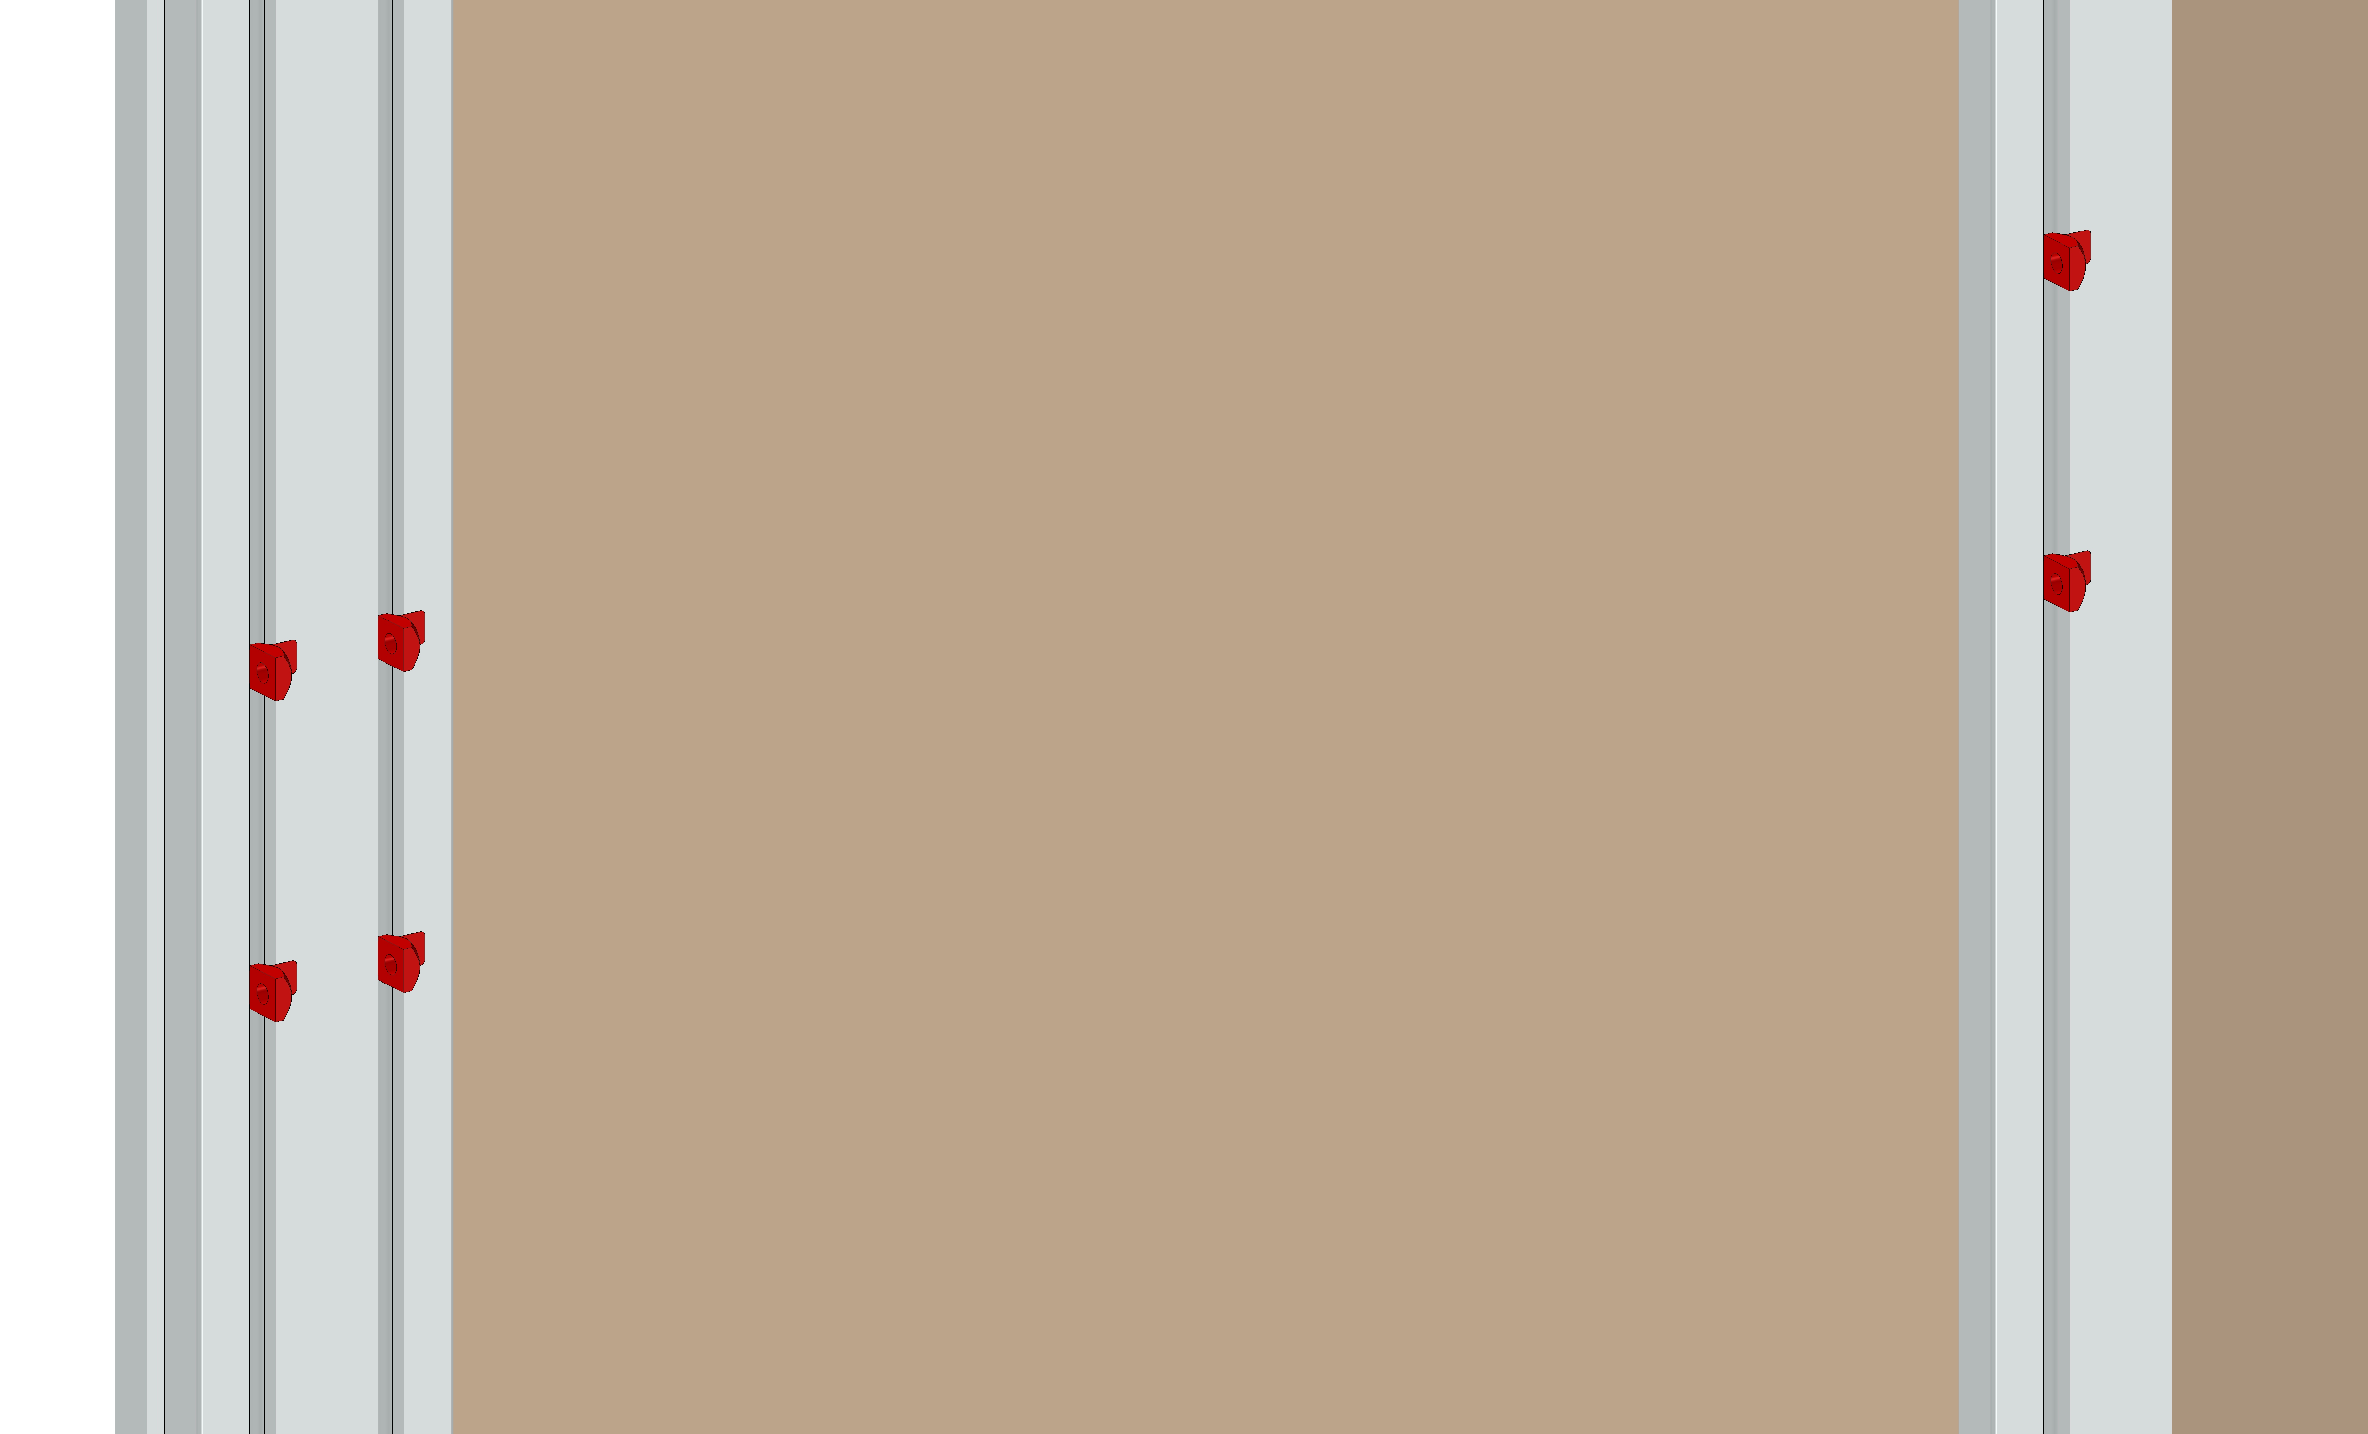
- Using a thin screwdriver, turn the nuts in the slot so that the thread is visible. The spring clip on the nut will hold the nut in place.
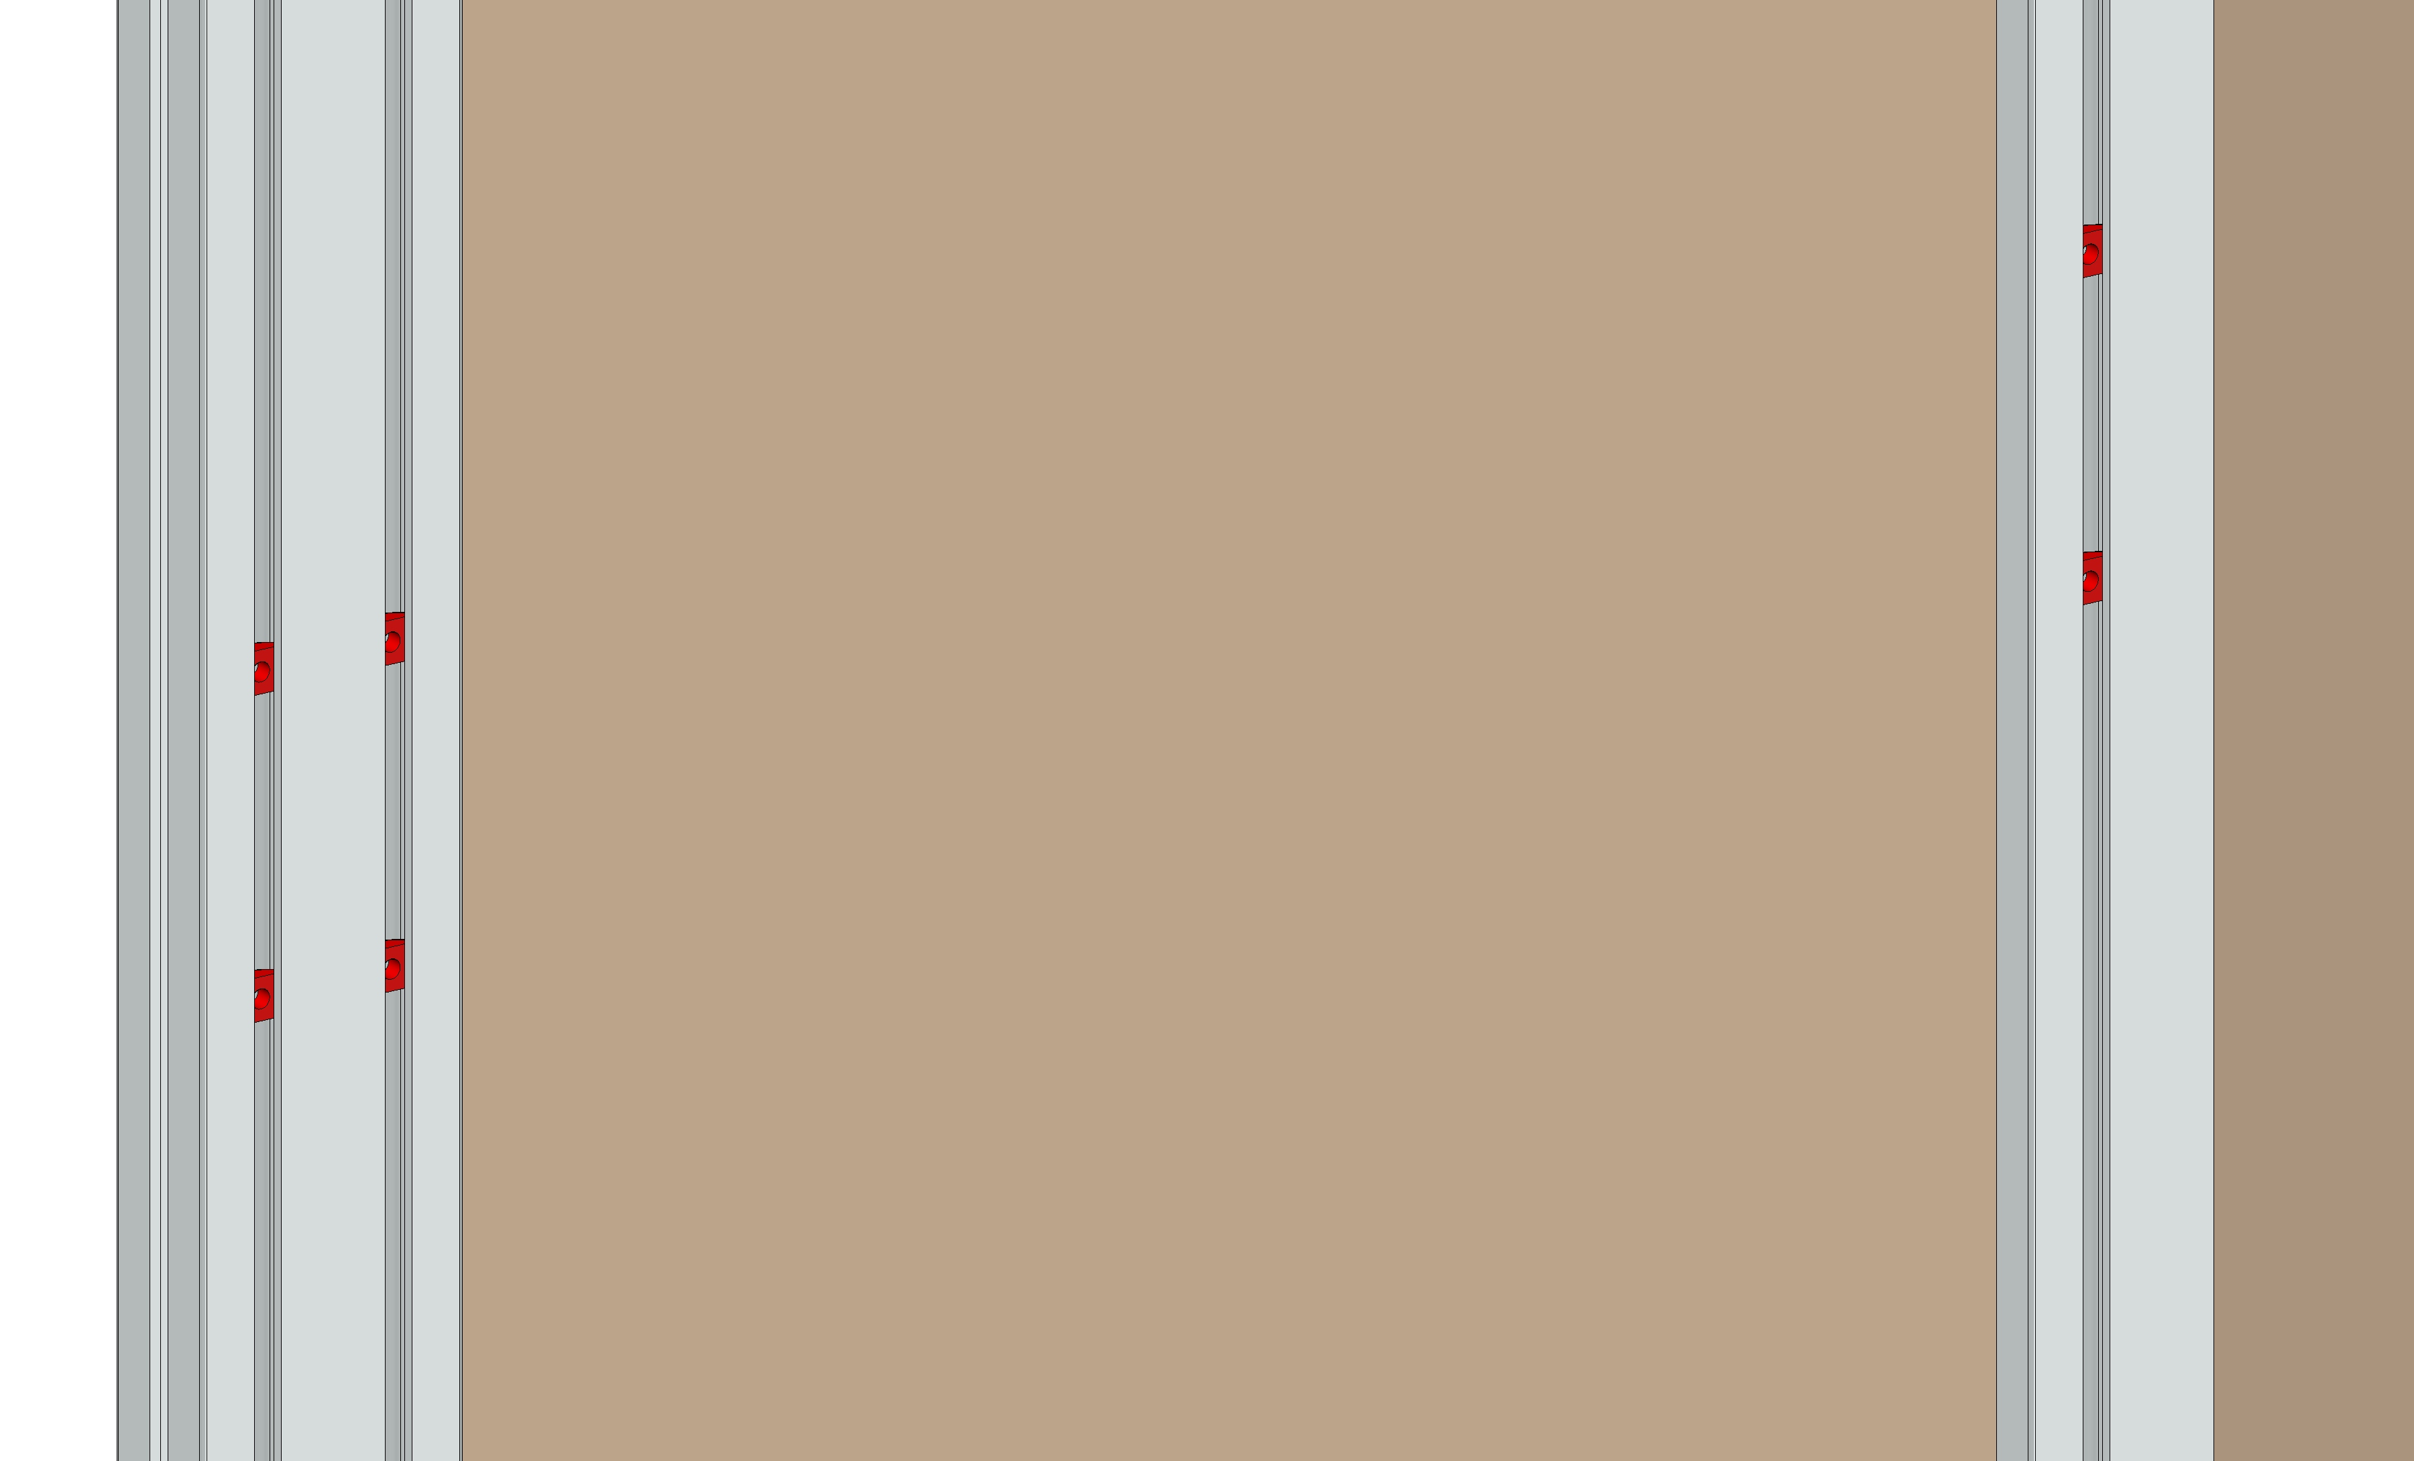
- Slide the nuts in the slots so that they are spaced approximately 67 mm apart and are at approximately the same levels.

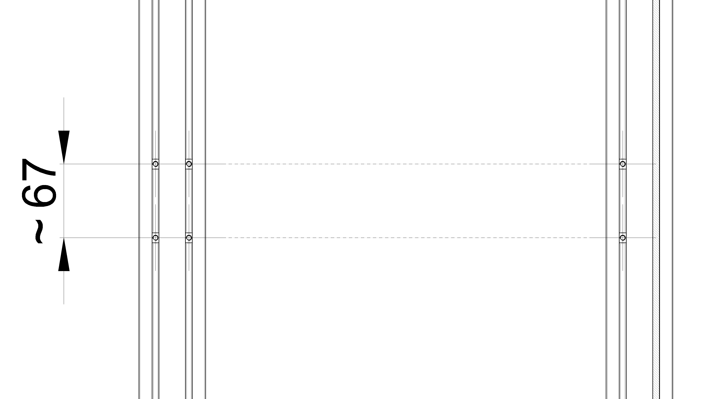
- Press the locking levers and remove the side panels from the drawer.

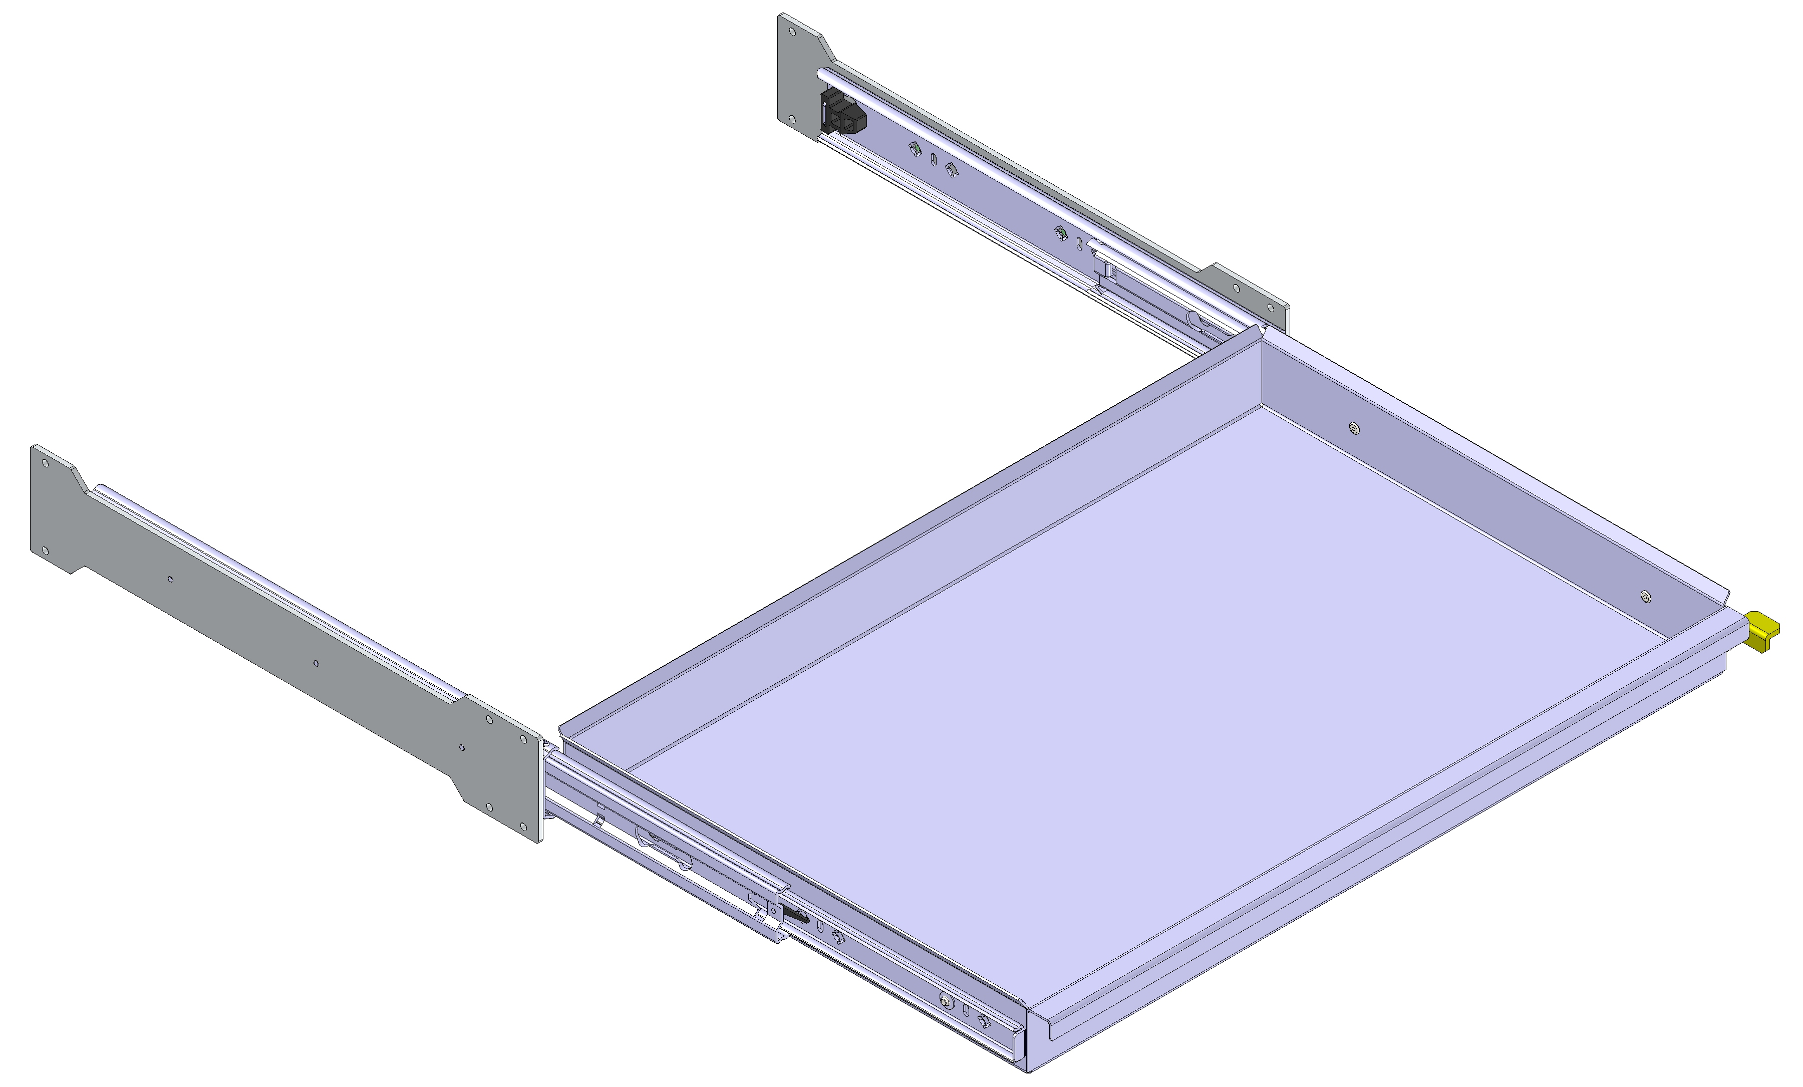
- Lightly tighten the side panel using the 6 supplied M5x12 screws.
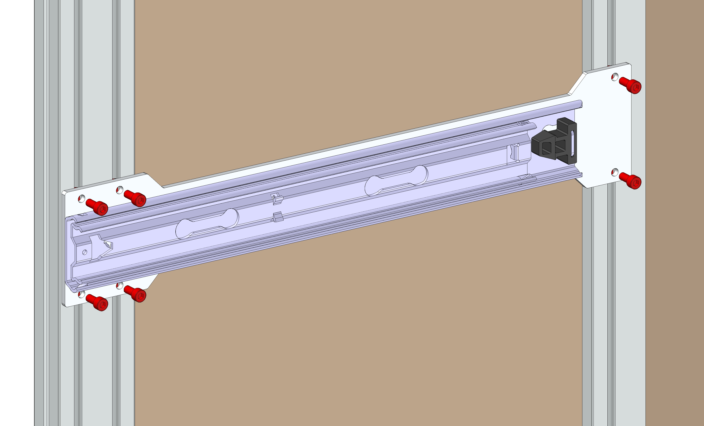
- Set both side panels to the required height. Make sure both drawer side panels are in the same position, parallel to each other and perpendicular to the frame.

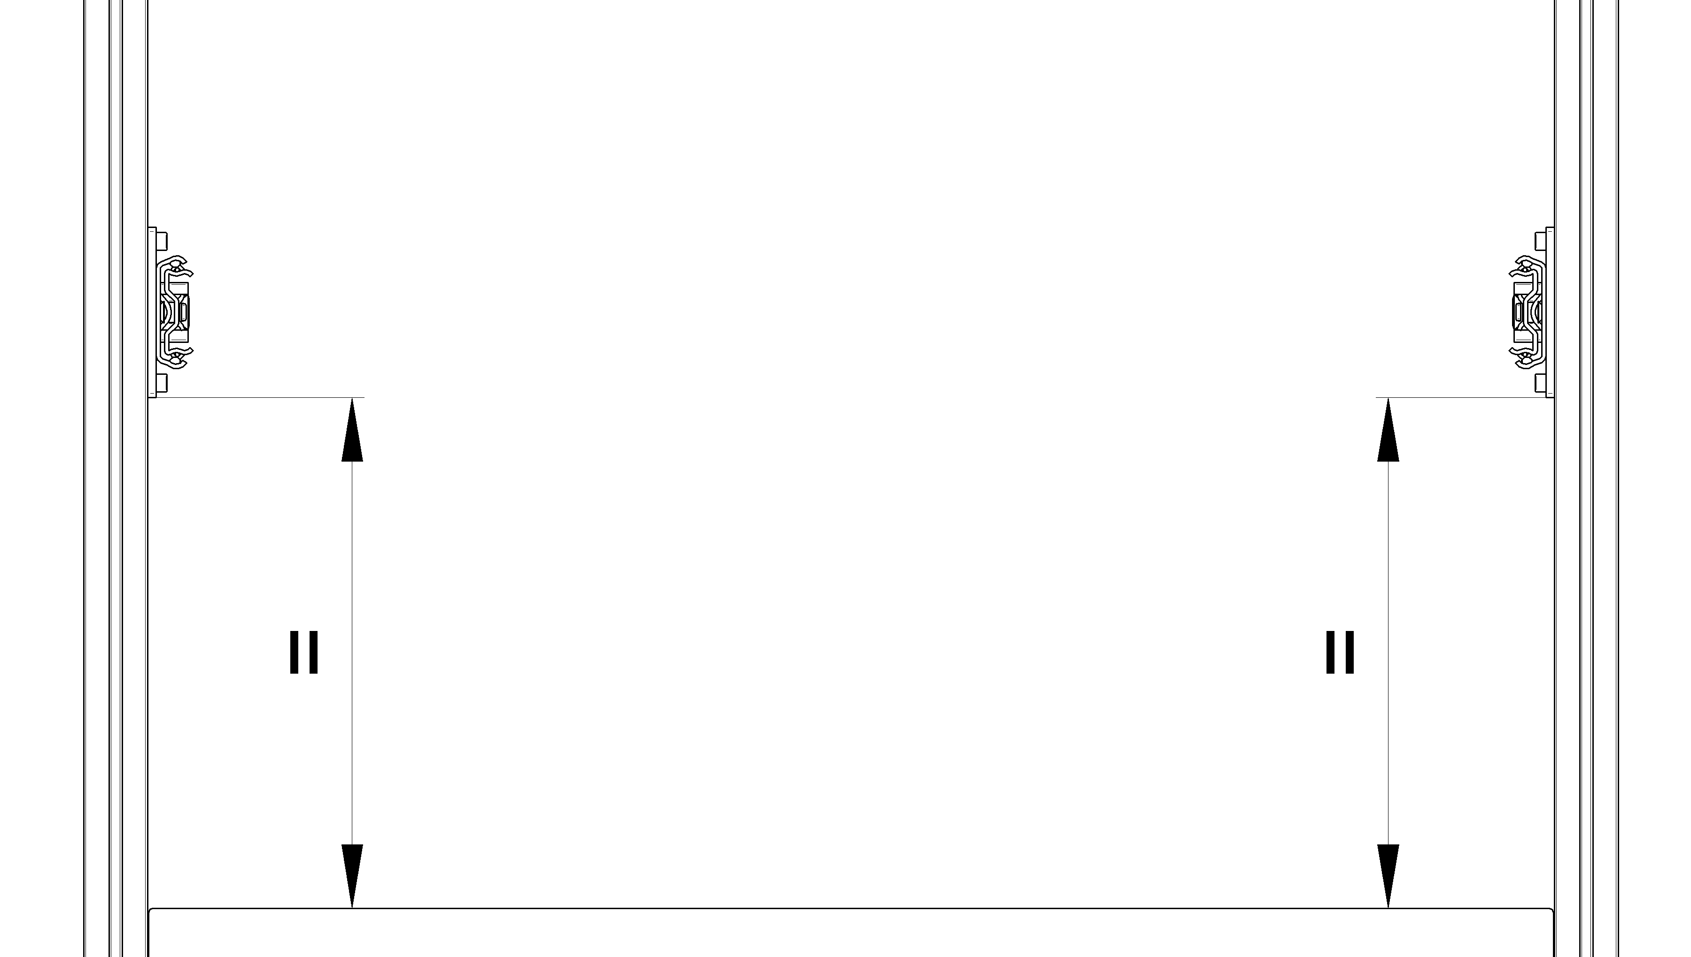

Note: For quick and accurate setting of drawer spacing for EURO crates, we recommend ordering the spacing fixtures shown in the picture.
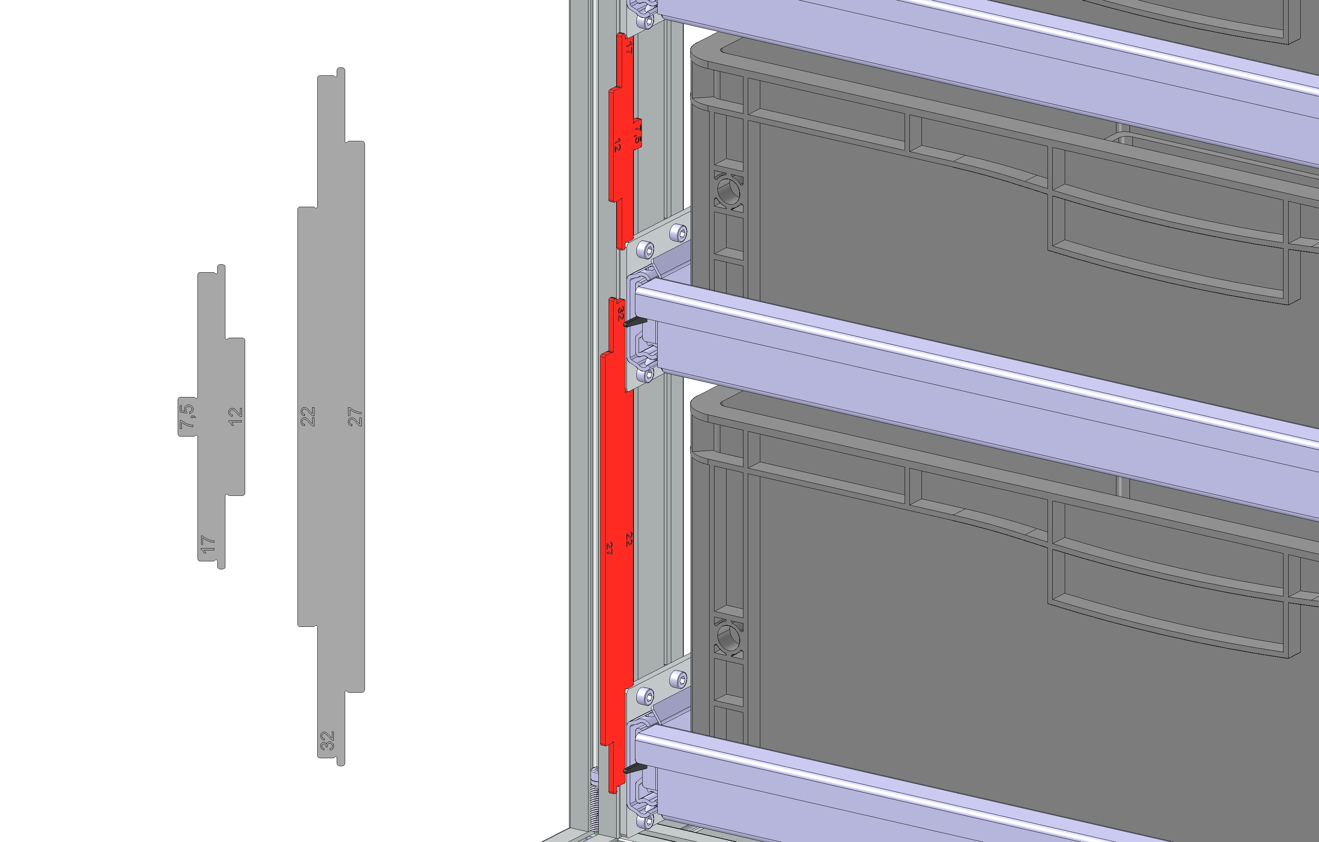

- After both side panels are in place, use a torque wrench to tighten all M5x12 screws to a tightening torque of 6 Nm.
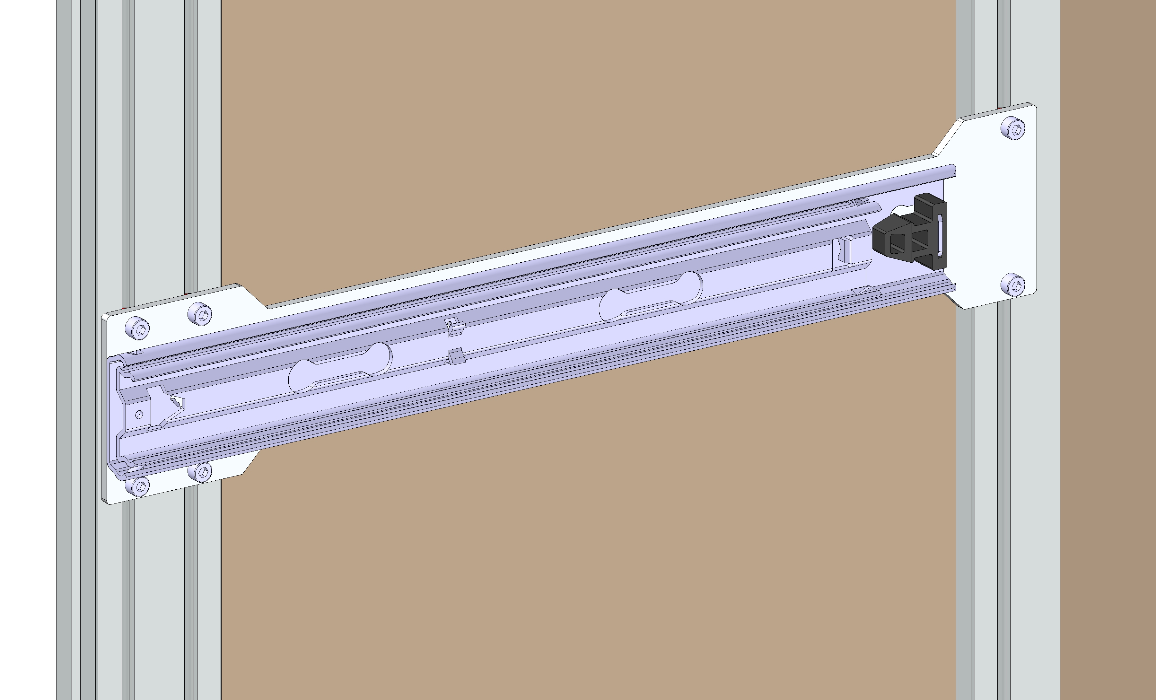
- Insert the drawer shelf into both slides until the shelf locks in place. Then check the shelf's motion, which should be smooth and free. If it is not, release the locking levers, pull the shelf out and recheck the position of both side panels.
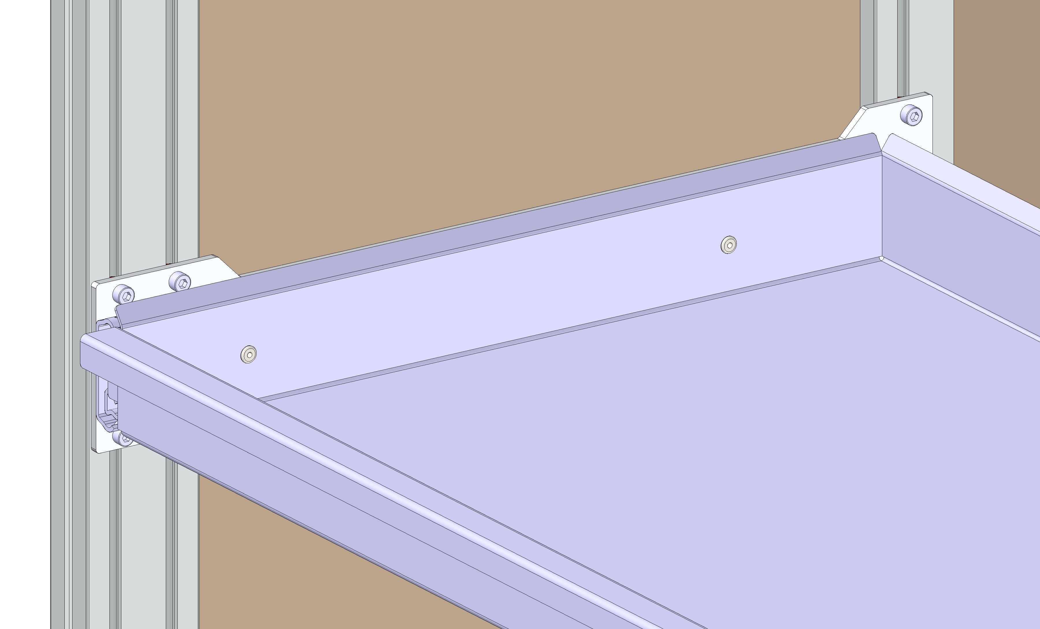

  - Disassembly
- Press both locking levers and pull the shelf out of the slides.
- Unscrew both side panels (12 M5x12 screws in total).
- Using a small screwdriver, turn the nuts in the slot so that the spring-clip side is visible.
- Using thin-nosed pliers, tweezers or a strong magnet, pull the nuts out of the slots (12 M5 nuts in total).
- Slide the side panels back onto the shelf and carefully store the fasteners.

- Warranty certificate
Subject of warranty: Heavy-duty mobile drawer rack
Serial number:
Warranty period: 12 months
  - Scope of warranty
The seller provides the buyer with a quality warranty for a period of 12 months from the date the product is taken over. The warranty covers manufacturing defects, material defects and functional design defects that prevent normal use of the item for its intended purpose.
  - 2. Warranty validity conditions
The warranty is valid only if the following conditions are met:
- The product has been used in accordance with this User Manual.
- The rack is not overloaded beyond the maximum load capacity specified by the manufacturer.
- The mobile mechanism (wheels) is operated on a level and firm surface.
- The product is used in an environment appropriate to its surface finish (indoor/dry environment).
  - Warranty exclusions
The warranty does not cover:
- Use contrary to the User Manual.
- Normal material wear (for example scratches on the paint, wear of shelves in use, wear of wheels).
- Damage caused by mechanical impact or improper handling.
- Defects caused by unauthorised modifications.
- Corrosion and damage caused by use in an unsuitable environment: humidity, outdoor use, highly corrosive environments.
- Damage caused by excessive thermal loading.
  - 4. Filing a claim
Defects must be reported without undue delay after they are discovered, in writing to the email address: info@inomech.tech together with a copy of the proof of purchase.

Date of sale: ...................................

Seller's stamp and signature: ...................................

